**OBJECT ORIENTED PROGRAMMING LAB**

**Co5 & Co6**

**Jomin K Mathew**

**TKM20MCA2021**

**Roll.no: 20MCA221**

**Program 1**

10/05/2021

**Aim:** Program to draw Circle, Rectangle, Line in Applet.

**Algorithm:**

Step.1: Start

Step.2: Define a class ‘appshape’ that extends Applet class.

Step.3: Draw a line, rectangle and circle using drawLine,

drawRect and drawOval methods of Graphics class

respectively.

Step.4: Stop

**Source Code:**

import java.applet.Applet;

import java.awt.*;

public class shapes extends Applet{

public void paint(Graphics g){

g.drawLine(50,30, 300, 30);

g.setColor(Color.BLUE);

g.fillRect(50, 80, 200, 40);

g.setColor(Color.RED);

g.fillOval(50,150,100,100);

g.setColor(Color.CYAN);

int x1[]={40, 130, 200, 50};

int y1[]={310, 260, 310, 310};

int n1=4;

g.fillPolygon(x1, y1, n1);

}

}

**Output:**

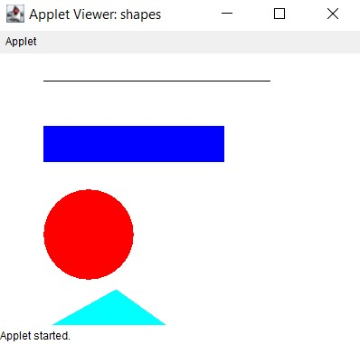

**Program 2**

10/05/2021

**Aim:** Program to draw Circle, Rectangle, Line in Applet.

**Algorithm:**

Step.1: Start.

Step.2: Define a class ‘largest’ that extends Applet class

and implements ActionListener interface.

Step.3: Using TextField class object, construct the required

no. of Text Fields wide enough to hold the values

entered by the user.

Step.4: Using Button class object, construct a labeled

button that sends an instance of ActionEvent.

Step 5: Call addActionListener() method to send

events from the button to the new listener.

Step 6: Get the string values from textfields and then

parse them as integers.

Step 7: Compare each value using if-else statements to

find the maximum value and set the result

accordingly.

Step.8: Stop

**Source Code:**

import java.awt.*;

import java.applet.*;

public class largest extends Applet

{

TextField Txt1,Txt2,Txt3;

public void init(){

Txt1 = new TextField(10);

Txt2 = new TextField(10);

Txt3 = new TextField(10);

add(Txt1);

add(Txt2);

add(Txt3);

Txt1.setText("num1");

Txt2.setText("num2");

Txt3.setText("num3");

}

public void paint(Graphics g){

int a, b, c,result;

String str;

g.drawString("Enter the numbers",10,50);

str=Txt1.getText();

a=Integer.parseInt(str);

str=Txt2.getText();

b=Integer.parseInt(str);

str=Txt3.getText();

c=Integer.parseInt(str);

if (a>b) {

if (a>c)

result=a;

else

result=c;

}

else{

if (b>c)

result=b;

else

result=c;

}

g.drawString("Largest number is "+result,10,70);

}

public boolean action(Event e, Object o){

repaint();

return true;

}

}

**Output:**

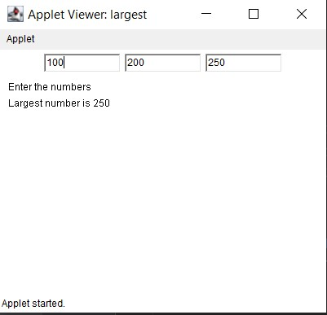

**Program 3**

10/05/2021

**Aim:** Find the percentage of marks obtained by a student in 5

subjects. Display a happy face if he secures above 50%

or a sad face if otherwise.

**Algorithm:**

Step 1: Start.

Step 2: Define a class ‘smile’ that extends Applet class and implements ActionListener interface.

Step 3: Using TextField class object, construct textfields to receive marks of 5 subjects from the user.

Step 4: Using Button class object, construct a labeled button that sends an instance of ActionEvent.

Step 5: Call addActionListener() method to send events from the button to the new listener.

Step 6: Get the string values from textfields and then parse them as float values.

Step 7: Calculate the percentage:percent =

((m1+m2+m3+m4+m5)*100)/500

Step 8: Define a paint() method that contains functions from

Graphics class to display a happy face if student

secures above 50% or a sad face if otherwise

Step 9: Stop.

**Source Code:**

import java.applet.*;

import java.awt.*;

import java.awt.event.*;

public class smile extends Applet implements ActionListener {

TextField t1,t2,t3,t4,t5,t6;

Button b;

Label l1,l2,l3,l4,l5,l6;

public void init(){

l1=new Label("mark1");

//l1.setBounds(100,100,200,20);

t1= new TextField(5);

//t1.setBounds(100,50,200,20);

l2=new Label("mark2");

//l2.setBounds(100,130,100,30);

t2= new TextField(5);

//t2.setBounds(100,80,100,20);

l3=new Label("mark3");

//l3.setBounds(100,160,100,20);

t3= new TextField(5);

//t3.setBounds(100,120,100,20);

l4=new Label("mark4");

//l4.setBounds(100,130,100,30);

t4= new TextField(5);

//t4.setBounds(100,80,100,20);

l5=new Label("mark5");

//l5.setBounds(100,130,100,30);

t5= new TextField(5);

//t5.setBounds(100,80,100,20);

l6=new Label("result");

//l6.setBounds(100,200,100,20);

t6=new TextField(5);

t1.setBounds(210,40,100,20);

t2.setBounds(210,80,100,20);

t3.setBounds(210,120,100,20);

t4.setBounds(210,80,100,20);

t5.setBounds(210,120,100,20);

t6.setBounds(210,140,100,20);

l1.setBounds(100,40,100,20);

l2.setBounds(100,80,100,20);

l3.setBounds(100,120,100,20);

l4.setBounds(100,140,100,20);

l5.setBounds(100,120,100,20);

l6.setBounds(100,140,100,20);

b=new Button("find");

b.setBounds(230,150,60,50);

//t4.setBounds(100,200,100,20);

add(l1);

add(t1);

add(l2);

add(t2);

add(l3);

add(t3);

add(l4);

add(t4);

add(l5);

add(t5);

add(b);

b.addActionListener(this);

add(l6);

add(t6);

}

public void actionPerformed(ActionEvent e){

int mark1=0;

int mark2=0;

int mark3=0;

int mark4=0;

int mark5=0;

int total=0;

mark1= Integer.parseInt(t1.getText());

mark2= Integer.parseInt(t2.getText());

mark3= Integer.parseInt(t3.getText());

mark4= Integer.parseInt(t2.getText());

mark5= Integer.parseInt(t3.getText());

if(e.getSource()==b){

total=(mark1+mark2+mark3+mark4+mark5)/5;

t6.setText(String.valueOf(total));

}

}

@Override

public void paint(Graphics g){

int mark1=0;

int mark2=0;

int mark3=0;

int mark4=0;

int mark5=0;

int total=0;

mark1= Integer.parseInt(t1.getText());

mark2= Integer.parseInt(t2.getText());

mark3= Integer.parseInt(t3.getText());

mark4= Integer.parseInt(t2.getText());

mark5= Integer.parseInt(t3.getText());

total=(mark1+mark2+mark3+mark4+mark5)/5;

g.setColor(Color.yellow);

g.fillOval(20,20,150,150); // For face

g.setColor(Color.black);

g.fillOval(50,60,15,25); // Left Eye

g.fillOval(120,60,15,25); // Right Eye

int x[] = {95,85,106,95};

int y[] = {85,104,104,85};

g.drawPolygon(x, y, 4); // Nose

g.fillPolygon(x, y, 4);

// g.drawLine(50,126,60,116); // Smile arc1

//g.drawLine(128,115,139,126); // Smile arc2

if(total > 50){

g.drawArc(55,95,78,50,0,-180); // Smile

}

else

{

g.drawArc(55,120,78,50,0,180); // Smile

}

}}

**Output:**

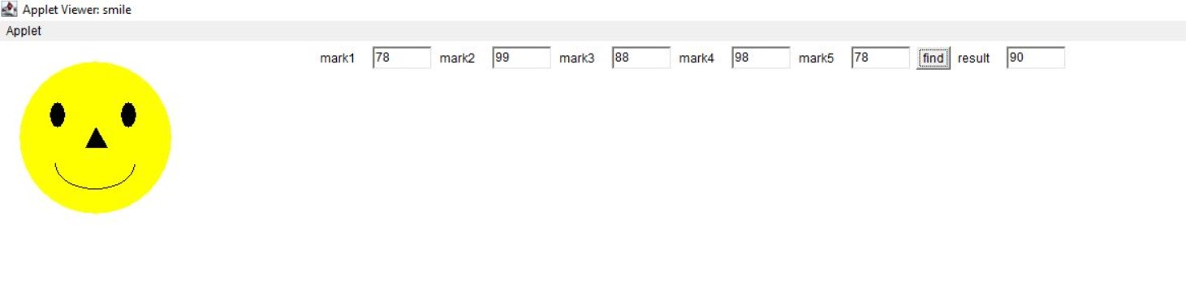

**Program 4**

10/05/2021

**Aim:** Using 2D graphics commands in an Applet, construct a

house. On mouse click event, change the color of the

door from blue to red.

**Algorithm:**

Step.1: Start.

Step.2: Define a class ‘MouseClick’ that extends Applet and implements MouseListener.

Step.3: Define methods to add MouseListener to the panel.

Step.4: Using getX() and getY() methods, get the coordinates of the door to repaint when the MousePressed event occurs.

Step.5: Stop.

**Source Code:**

import java.awt.*;

import java.applet.*;

import java.awt.Graphics;

import java.awt.event.*;

public class MouseClick extends Applet implements MouseListener

{

int a,b;

public void init()

{

addMouseListener(this);

}

public void paint(Graphics gp)

{ int [] x = {170, 280, 300,150};

int [] y = {100, 100, 150, 150};

gp.setColor(Color.cyan);

gp.fillRect(150, 150, 150, 200); //House

gp.drawRect(200, 200, 50, 150); // Door

gp.setColor(Color.pink);

gp.fillRect(200,200,50,150);

gp.setColor(Color.gray);

gp.fillPolygon(x,y,4);

if(a>200 && a<300 && b>200 && b<300)

{

gp.setColor(Color.orange);

gp.fillRect(200, 200, 50, 150);

}

}

public void mouseClicked(MouseEvent e)

{

}

public void mouseEntered(MouseEvent e)

{

}

public void mouseExited(MouseEvent e) {

}

public void mousePressed(MouseEvent e)

{

a=e.getX();

b=e.getY();

repaint();

}

public void mouseReleased(MouseEvent e)

{

}

}

**Output:**

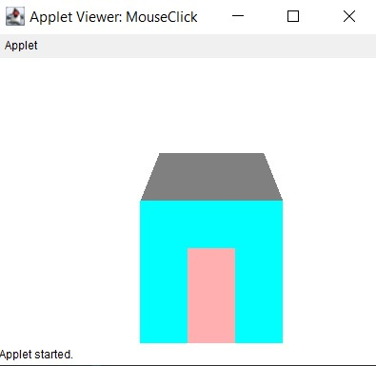

**Program 5**

10/05/2021

**Aim:** Implement a simple calculator using AWT

components.

**Algorithm:**

Step.1: Start.

Step.2: Define a class ‘calculator’ that extends Frame and implements ActionListener interface.

Step.3: Using TextField class object, construct the required no. of textfields wide enough to hold the values entered by the user.

Step.4: Using Label class object, construct and provide the appropriate labels.

Step.5: Using Button class object, construct labeled buttons that send the instances of ActionEvent.

Step.6: Call addActionListener() method to send events from the button to the new listener.

Step.7: Get the string values from textfields and then parse them as integers.

Step.8: Perform various methods to add, subtract, multiply and divide those integers.

Step.9: Stop.

**Source Code:**

import java.awt.*;

import java.awt.event.*;

class calculator implements ActionListener {

Frame f = new Frame();

Label l1 = new Label("1st Integer");

Label l2 = new Label("2nd Integer");

Label l3 = new Label("Result");

TextField t1 = new TextField();

TextField t2 = new TextField();

TextField t3 = new TextField();

Button b1 = new Button("Add");

Button b2 = new Button("Sub");

Button b3 = new Button("Mul");

Button b4 = new Button("Div");

calculator() {

l1.setBounds(50, 100, 100, 20);

l2.setBounds(50, 150, 100, 20);

l3.setBounds(50, 200, 100, 20);

t1.setBounds(200, 100, 100, 20);

t2.setBounds(200, 150, 100, 20);

t3.setBounds(200, 200, 100, 20);

b1.setBounds(50, 250, 50, 20);

b2.setBounds(110, 250, 50, 20);

b3.setBounds(170, 250, 50, 20);

b4.setBounds(230, 250, 50, 20);

f.add(l1);

f.add(l2);

f.add(l3);

f.add(t1);

f.add(t2);

f.add(t3);

f.add(b1);

f.add(b2);

f.add(b3);

f.add(b4);

b1.addActionListener(this);

b2.addActionListener(this);

b3.addActionListener(this);

b4.addActionListener(this);

f.setLayout(null);

f.setVisible(true);

f.setSize(500, 500);

}

public void actionPerformed(ActionEvent e) {

int i = Integer.parseInt(t1.getText());

int j = Integer.parseInt(t2.getText());

if (e.getSource() == b1) {

t3.setText(String.valueOf(i + j));

}

if (e.getSource() == b2) {

t3.setText(String.valueOf(i - j));

}

if (e.getSource() == b3) {

t3.setText(String.valueOf(i * j));

}

if (e.getSource() == b4) {

t3.setText(String.valueOf(i / j));

}

}

public static void main(String[] args)

{

new calculator();

}

}

**Output:**

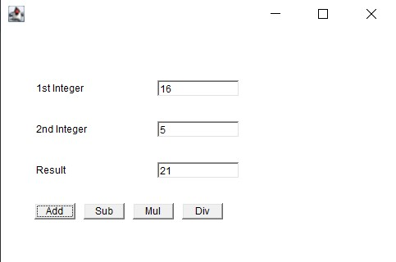

**Program 6**

10/05/2021

**Aim:** Develop a program that has a Choice component which

contains the names of shapes such as rectangle,

triangle, square and circle. Draw the corresponding

shapes for given parameters as per user’s choice.

**Algorithm:**

Step.1: Start the program.

Step.2: Define a class ‘Shape’ that extends Applet class and implements ItemListener interface.

Step.3: Declare a new constructor of the Choice class to create an empty Choice menu.

Step.4: Use add() method to include items in the menu.

Step.5: Using getSelectedItem() method, get the item chosen by the user from the menu and repaint accordingly.

Step.6: Stop the program.

**Source Code:**

import java.applet.Applet;

import java.awt.*;

import java.awt.Graphics;

import java.awt.event.*;

public class Shape extends Applet implements ItemListener

{

Choice choice;

int rectX;

int rectY;

int rectWidth ;

int rectHeight;

String shape;

int Selection;

public void init()

{

choice = new Choice();

choice.addItem("Choose the shape");

choice.addItem("Rectangle");

choice.addItem("Triangle");

choice.addItem("Square");

choice.addItem("Circle");

add(choice);

choice.addItemListener(this);

}

public void itemStateChanged (ItemEvent e)

{

// set new selection index

Selection = choice.getSelectedIndex();

repaint();

}

public void paint(Graphics g)

{

super.paint(g);

if (Selection == 1)

{

g.setColor(Color.BLUE);

g.fillRect(70,70,200,130);

g.drawRect(70,70,200,130);

}

if (Selection == 2)

{

int xArray[] ={110,180,30,110};

int yArray[] ={30,100,100,30};

g.setColor(Color.green);

g.fillPolygon(xArray,yArray,4);

}

if (Selection == 3)

{

g.setColor(Color.BLACK);

g.fillRect(150,150,100,100);

g.drawRect(150,150,100,100);

}

if (Selection ==4)

{

g.setColor(Color.red);

g.fillOval(130,100,190,190);

g.drawOval(130,100,190,190);

}

}

}

**Output:**

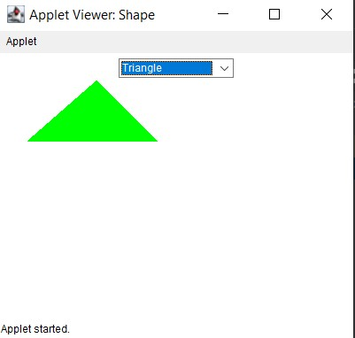

**Program 7**

10/05/2021

**Aim:** Develop a program to handle all mouse events and

window events.

**Algorithm:**

Step 1: Start

Step 2: Define a class ‘MouseWindowEvent’ that extends Applet class and implements MouseListener interface

Step 3: Define methods to add MouseListener to the panel

Step 4: Using getX() and getY() methods, get the location (or movements) of mouse pointer on the panel. Use them to display the necessary message in the output.

Step 5: Define another class WindowEvents that extends Applet class and implements WindowListener interface.

Step 6: Define methods to add WindowListener to the panel

Step 7: Display the appropriate message in the output

Step 8: Stop

**Source Code:**

import java.awt.*;

import java.awt.event.MouseEvent;

import java.awt.event.MouseListener;

import java.awt.event.WindowEvent;

import java.awt.event.WindowListener;

public class MouseWindowEvent extends Frame implements MouseListener{

Label l;

MouseWindowEvent(){

addMouseListener(this);

l=new Label();

l.setBounds(20,50,100,20);

add(l);

setSize(300,300);

setLayout(null);

setVisible(true);

}

public void mouseClicked(MouseEvent e) {

l.setText("Mouse Clicked");

}

public void mouseEntered(MouseEvent e) {

l.setText("Mouse Entered");

}

public void mouseExited(MouseEvent e) {

l.setText("Mouse Exited");

}

public void mousePressed(MouseEvent e) {

l.setText("Mouse Pressed");

}

public void mouseReleased(MouseEvent e) {

l.setText("Mouse Released");

}

public static void main(String[] args) {

new MouseListenerExample();

new WindowExample();

}

}

class WindowExample1 extends Frame implements WindowListener{

WindowExample1(){

addWindowListener(this);

setSize(400,400);

setLayout(null);

setVisible(true);

}

public void windowActivated(WindowEvent arg0) {

System.out.println("activated");

}

public void windowClosed(WindowEvent arg0) {

System.out.println("closed");

}

public void windowClosing(WindowEvent arg0) {

System.out.println("closing");

dispose();

}

public void windowDeactivated(WindowEvent arg0) {

System.out.println("deactivated");

}

public void windowDeiconified(WindowEvent arg0) {

System.out.println("deiconified");

}

public void windowIconified(WindowEvent arg0) {

System.out.println("iconified");

}

public void windowOpened(WindowEvent arg0) {

System.out.println("opened");

}

}

**Output:**

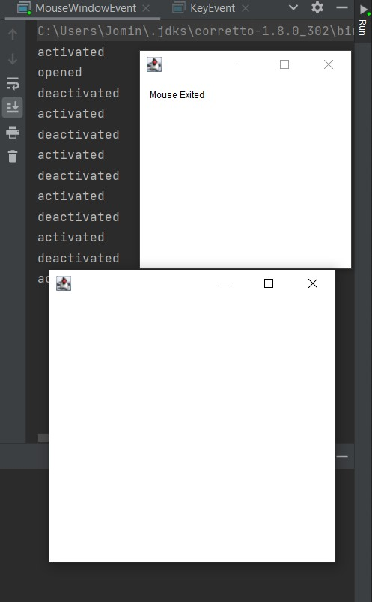

**Program 8**

10/05/2021

**Aim:** Develop a program to handle Key events.

**Algorithm:**

Step.1: Start.

Step.2: Define a class ‘KeyEvents’ that extends Applet and implements KeyListener.

Step.3: Define methods to add KeyListener to the panel which will have the following methods:

void keyTyped(KeyEvent e) – Invoked when a key has been typed.

void keyPressed(KeyEvent e) - Invoked when a key has been pressed.

void keyReleased(KeyEvent e) - Invoked when a key has been released.

Step.4: Using getKeyChar(), get the unicode and character representation of the key pressed. Use them to display the necessary message in the output.

Step.5: Stop.

**Source Code:**

import java.awt.*;

import java.awt.event.*;

import java.awt.event.KeyEvent;

public class KeyEvents extends Frame implements

KeyListener{

Label l;

TextArea area;

KeyEvents(){

l=new Label();

l.setBounds(20,50,100,20);

area=new TextArea();

area.setBounds(20,80,300, 300);

area.addKeyListener(this);

add(l);add(area);

setSize(400,400);

setLayout(null);

setVisible(true);

}

public void keyPressed(KeyEvent e) {

l.setText("Key Pressed");

}

public void keyReleased(KeyEvent e) {

l.setText("Key Released");

}

public void keyTyped(KeyEvent e) {

l.setText("Key Typed");

}

public static void main(String[] args) {

new KeyListenerExample();

}

}

**Output:**

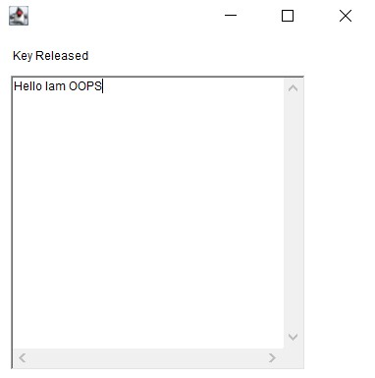

**Program 9**

10/05/2021

**Aim:** Program to list the sub directories and files in a given

directory and also search for a file name.

**Algorithm:**

Step 1: Start

Step 2: Create a class named ‘Listfile’ that implements FilenameFilter interface

Step 3: Create an object for the class File to to initialize its constructor with the file source

Step 4: Using list(), get the names of all the files present in the directory

Step 5: Create an object for the FileNameFilter interface that contains the method Boolean accept ( File dir, String fname) to test if a specified file should be included in the file list or not

Step 6: Filter accordingly and store the file names to the list

Step 7: Display the list

Step 8: Stop

**Source Code:**

package packoops;

import java.io.File;

class Listfile {

public static void main(String[] args) {

File file = new File("C:\\Users\\jomin\\Desktop");

String[] fileList = file.list();

for(String str: fileList) {

System.out.println(str);

}

}

}

**Output:**

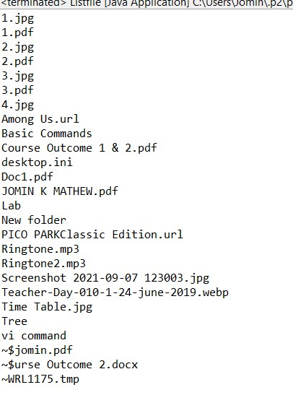

**Program 10**

10/05/2021

**Aim:** Write a program to write to a file, then read from the

file and display the contents on the console.

**Algorithm:**

Step 1: Start.

Step 2: Create a class named ‘write’.

Step 3: Create an object of the class File to initialize its constructor with the file source.

Step 4: Create and use an object for the FileWriter class to write the file.

Step 5: Create and use an object for the BufferedReader class to read the stream of characters the specified file.

Step 6: Display the contents read from the file on the console.

Step 7: Stop.

**Source Code:**

import java.io.File;

import java.io.IOException;

import java.io.FileWriter;

import java.util.Scanner

public class write

{

public static void main(String[] args) {

try {

Scanner re=new Scanner(System.in);

FileWriter obj = new FileWriter("D:\\programming\\file.txt");

System.out.println("Write mode ON....." +

"");

String a= re.nextLine();

obj.write(a);

obj.close();

System.out.println("Successfully written");

File obk = new File("D:\\programming\\file.txt");

System.out.println("Read mode ON....." +

"");

Scanner reada=new Scanner(obk);

while(reada.hasNextLine()){

String data= reada.nextLine();

System.out.println(data);

}

reada.close();

} catch (IOException e) {

System.out.println("Error Occurred");

e.printStackTrace();

}

}

}

**Output:**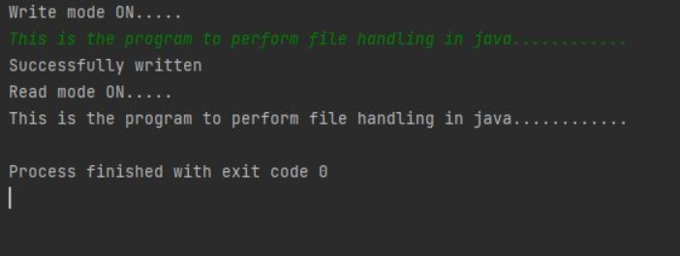

**Program 11**

10/05/2021

**Aim:** Write a program to copy one file to another.

**Algorithm:**

Step 1: Start.

Step 2: Create a class named ‘copy’.

Step 3: Create and use an object for the FileReader class to read the stream of characters from the specified file.

Step 4: Create and use an object for the FileWriter class to write the stream of characters read by the FileReader, to the file.

Step 5: Stop

**Source Code:**

import java.io.*;

import java.util.*;

public class copy {

public static void main(String[] args) throws Exception{

Scanner re = new Scanner(System.in);

System.out.println("Enter the path of the source file");

String sc=re.next();

System.out.println("Enter the path of the destination file:");

String dc=re.next();

System.out.println("Copying........");

FileReader ra= new FileReader(sc);

FileWriter wr =new FileWriter(dc,true);

int c;

while((c= ra.read()) !=-1){

wr.write(c);

}

System.out.println("Copied........");

ra.close();

wr.close();

}

}

**Output:**

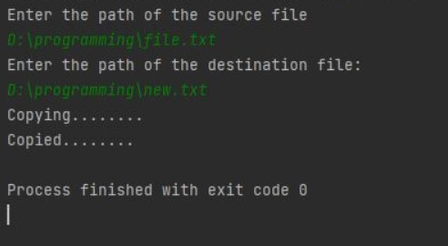

**Program 12**

10/05/2021

**Aim:** Write a program that reads from a file having integers.

Copy even numbers and odd numbers to separate files.

**Algorithm:**

Step 1: Start

Step 2: Create a class named ‘evenodd’

Step 3: Create an object for the class File to initialize its constructor with the given file.

Step 4: Get user inputs via the console, for the integers to be inserted into the file.

Step 5: Using an object for the FileWriter class, write those integers into the file.

Step 6: Using objects for the FileOutputStream class, create two separate files to store even and odd integers respectively and copy the integers accordingly to separate files just created.

Step 7: Stop

**Source Code:**

import java.io.FileInputStream;

import java.io.FileOutputStream;

import java.io.IOException;

class evenodd {

public static void main(String[] args) throws IOException {

FileInputStream fr = new FileInputStream("D:\\MCA\\Sem 2\\oops lab\\Course Outcomes\\CO6\\prgrm4\\Numbers.txt");

FileOutputStream fw1 = new FileOutputStream("D:\\MCA\\Sem 2\\oops lab\\Course Outcomes\\CO6\\prgrm4\\Even Numbers.txt");

FileOutputStream fw2 = new FileOutputStream("D:\\MCA\\Sem 2\\oops lab\\Course Outcomes\\CO6\\prgrm4\\Odd Numbers.txt");

System.out.println("Even & Odd numbers copied to seperate files");

int i;

while((i=fr.read()) != -1)

{

if(i%2==00)

fw1.write(i);

else

fw2.write(i);

}

fr.close();

fw1.close();

fw2.close();

}

}

**Output:**

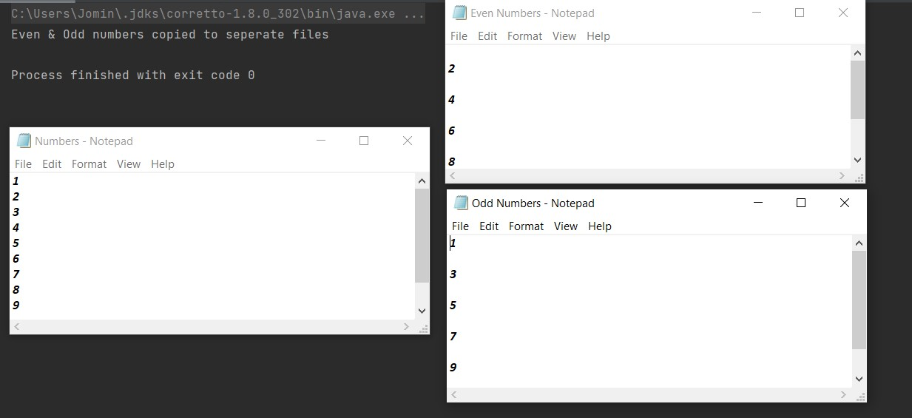

**Program 13**

10/05/2021

**Aim:** Client server communication using Socket – TCP/IP.

**Algorithm:**

Step 1: Start

Step 2: To create the Client application, create an instance of ClientSocket class

Step 3: To create the Server application, create an instance of ServerSocket class

Step 4: Stop

**Source Code:**

*server.java*

import java.net.*;

import java.io.*;

class server {

public static void main(String[] args) throws Exception {

try {

ServerSocket ss = new ServerSocket(2665);

System.out.println("Server is waiting .....");

Socket s = ss.accept();

System.out.println("CONNECTION ESTABLISHED !!!");

InputStreamReader isr = new InputStreamReader(s.getInputStream());

BufferedReader br = new BufferedReader(isr);

String str = br.readLine();

System.out.println("Message from Client: "+str);

PrintWriter pw = new PrintWriter(s.getOutputStream(), true);

pw.println("Hello Client!!.");

pw.close();

}

catch(Exception e) {

System.out.println("An error occured.."+e);

}

}

}

*client.java*

import java.net.*;

import java.io.*

class client {

public static void main(String args[]) throws Exception{

try {

Socket s = new Socket ("localhost", 2665);

PrintWriter pw = new PrintWriter(s.getOutputStream(), true);

pw.println("Hello Server!!");

//Client is reading from its InputStream

InputStreamReader isr = new InputStreamReader(s.getInputStream());

BufferedReader br = new BufferedReader(isr);

String str= br.readLine();

System.out.println("Message from Server: "+str);

pw.close();

s.close();

}

catch(Exception e) {

System.out.println("An error occured..." +e);

}

}

}

**Output:**

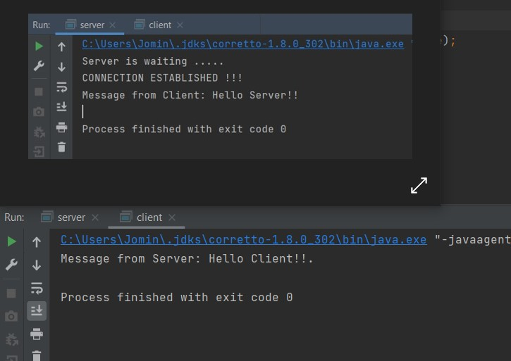

**Program 14**

10/05/2021

**Aim:** Client Server communication using DatagramSocket –

UD.

**Algorithm:**

Step 1: Start

Step 2: Create the Client application

Step 3: Create the Server application

Step 4: Stop

**Source Code:**

*serverudp.java*

import java.io.*;

import java.net.*

public class serverudp {

public static void main(String[] args) throws IOException {

DatagramSocket server=new DatagramSocket(4220);

byte[] buf=new byte[256];

DatagramPacket packet=new DatagramPacket(buf,buf.length);

server.receive(packet);

String reply =new String(packet.getData());

System.out.println("\n Client Says : "+reply);

server.close();

}}

*clientudp.java*

import java.io.*;

import java.net.*;

public class clientudp {

public static void main(String[] args) throws IOException {

DatagramSocket client= new DatagramSocket();

InetAddress add=InetAddress.getByName("localhost");

String str ="Hello Server!!!";

byte[] bufBytes = str.getBytes();

DatagramPacket datagramPacket=new DatagramPacket(bufBytes,bufBytes.length,add,4220);

client.send(datagramPacket);

client.close();

}

}

**Output:**

